**Azure Virtual Network**



Azure Virtual Network (VNet) is a logically isolated network in Azure that enables secure communication between Azure resources, on-premises networks, and the internet. It supports subnets, IP address management, network security, and service endpoints.

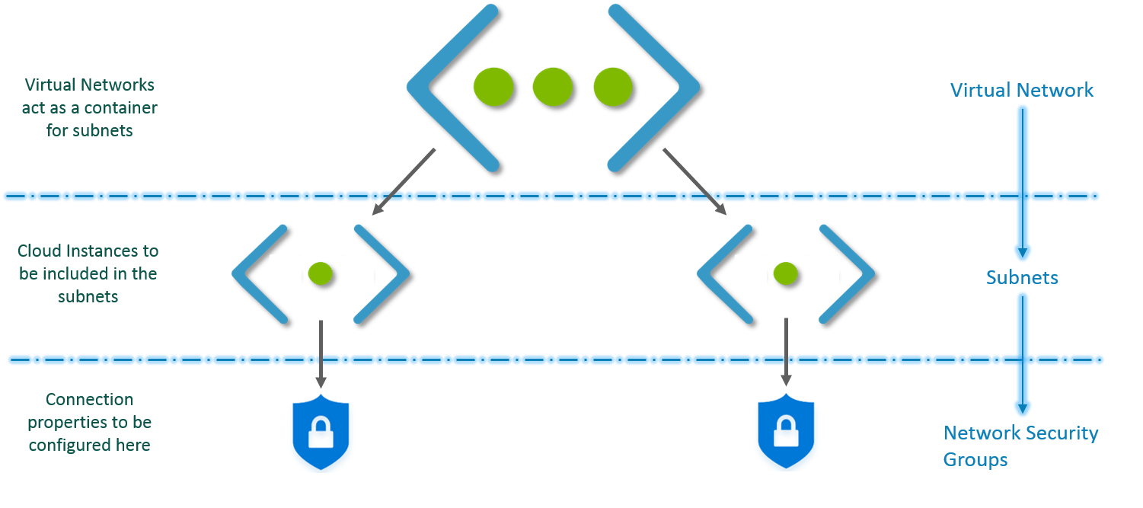

**Virtual Network** **Interface :** A Virtual Network Interface (NIC) in Azure connects a virtual machine (VM) to a Virtual Network (VNet). It enables network communication for the VM, including assigning private/public IPs, network security groups, and routing.

IP Address : Unique device network identifier.

Public IP Address : Globally accessible network identifier.

Private IP Address : Internal network device identifier.

Subnets : Subdivisions of virtual networks.

**Point to Site** **Network :**

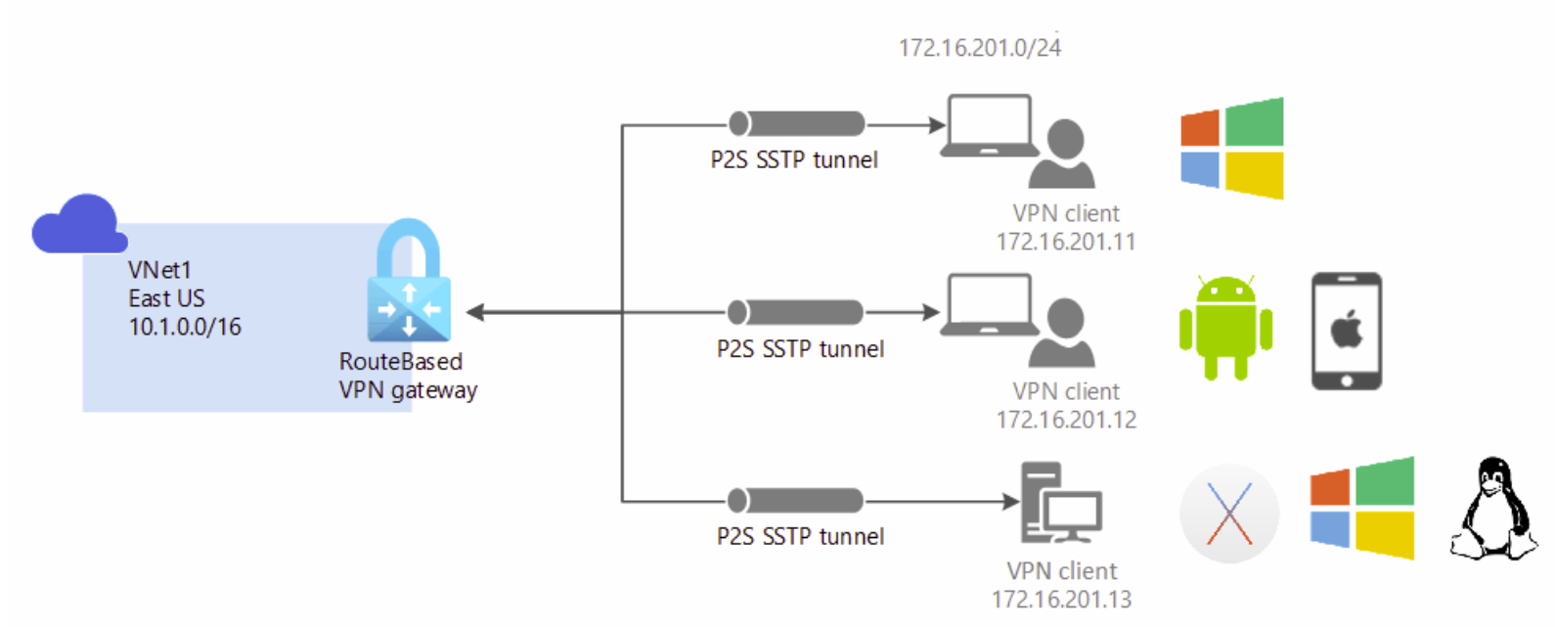

**Site to Site** **Network :**

